CO2-AT-2
Assessment tool-2

1. Morphological Processing
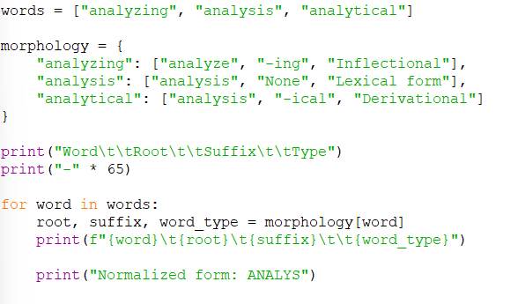

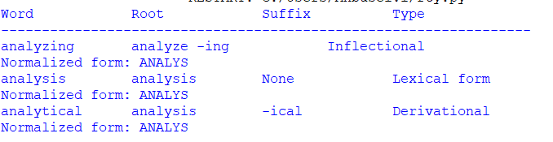
----------------------------------------------------------------------------------------------
2. Morphological Parsing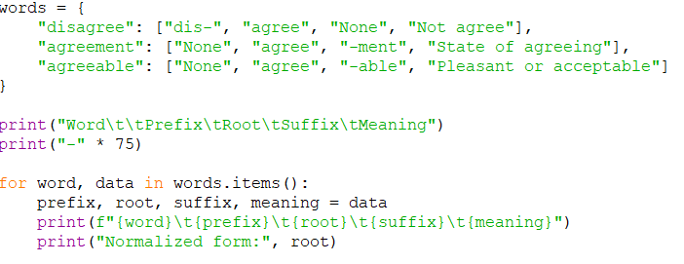
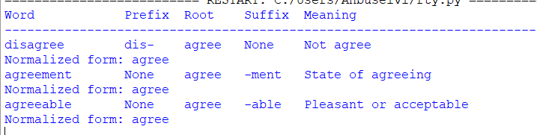
---------------------------------------------------------------------------------------------
3. Morphological Normalization

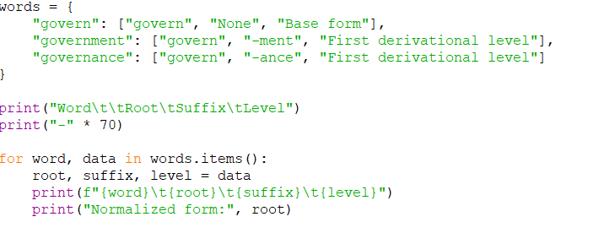
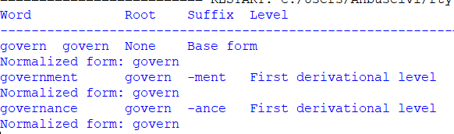
--------------------------------------------------------------------------------------------

4. Morphological Parsing and Normalization

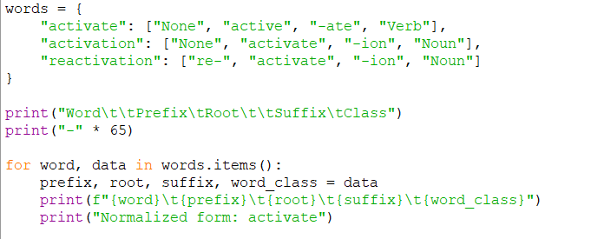

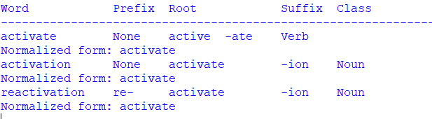
------------------------------------------------------------------------------------------
5. Inflectional Morphology
